LECTURE 2 CURIOUS INCIDENT OF THE DOG IN THE NIGHT-TIME
www.multimodalme.wordpress.com

MODULE B
Close study of a text examines features, structure, forms and ideas and how they shape meaning. In this unit we establish the distinctive qualities of a text and discuss how they effect the perceptions of responses.
CONTEXT
The book was written in 1998 at the end of the 20th Century. It is set in contemporary Swindon. Swindon is a town between Bristol and London in England. Haddon’s knowledge of Aspergers Syndrome comes from working with Autistic people as a young man.
AUDIENCE
Aimed simultaneously at youth and adult readers
PURPOSE
To challenge our understanding of marginalized people because of their differences. Gives us insight into not only Christopher but also other characters and allows us to develop empathy with people who have overcome difficulties with humour and intelligence.
IMPACT
The impact of this novel was vast. It is now a stage play. It started a conversation about acceptance and understanding.
TITLE
Is a literary allusion
GENRE
Crime Fiction: Details slowly revealed to solve mystery.
VOICE
First person perspective: an unusual narrator
DON’T EXPLAIN THE TECHNIQUES AS MUCH AS THEIR IMPACT ON THE AUDIENCE!
USE THE METALANGUAGE
- Difficulty building social relationships
- Difficulty communicating effectively
- Clumsy
- Sensory sensitivity
- Special interest and Routine
- Highly intelligent.
WHEN WRITING ABOUT TECHNIQUES
- You don’t need a new sentence for every technique
- Do not say “…used the technique of….
- Speak structurally (Orientation as opposed to opening chapters)
- Say Wellington rather than the dog.
- Use broad techniques and expand on them, and use other techniques within.
LINEAR NARRATIVE STRUCTURE
We follow the protagonist as he deals with situations
Orientation – Christopher finds Wellington stabbed
Complication – Christopher investigates Wellingtons death and finds out his mother is not dead.
Rising Action – Ed Boone lies about his wife’s death. Christopher no-longer trusts him. Christopher goes to London to find his mother.
Climax – Roger(Mr Shears) screams at Christopher and Roger and Judy (Christopher’s mother) Break up.
Resolution – Judy takes Christopher back to Swindon where he completes his A level maths and makes plans for the future.
The relationships between characters are vastly different at the end compared to the beginning.
STRUCTURAL FEATURES
Structure comprises not only of the narrative structure just mentioned but there are also other structural features of this text.
Chapters are identified through prime numbers. Christopher’s love of Prime numbers is a paradox. He loves prime numbers despite not understanding the pattern which is contradictory to his love of order (page 15) Haddon’s use of prime numbers is designed to make us uncomfortable.
Haddon also alternates chapters of action and insight. Each chapter consists of either something happening in the story OR Christopher’s musings about life.
LANGUAGE AND STYLE
Sentences and paragraphing:
Lengths vary depending on Christopher’s mood. For example on page 184-185 there are a series of short sentences starting with “and”. This repetition takes us in to Christopher’s world as he tries to calm and centre himself by working through the situation.
Christopher doesn’t understand metaphors. He doesn’t understand nuances or connotation of language. He uses similes “stacking up like loaves…” “looked like the surface of a planet” to make connections between the world around him with the things he is familiar with.
SYMBOLISM
Maths is a reoccurring motif. Christopher easily works through maths problems and logic however no matter how much he experiences or tries to put things together he will never understand human emotion.
Christopher uses precise descriptions of the material world not verbose and poetic, literal and specific.
LANGUAGE CHOICE
Christopher uses formal language and is matter of fact. The adults in the book use more colloquial and offensive language. This is the opposite of what we would usually expect. The adult language style doesn’t change throughout the novel.
THEMES/ IDEAS/ ISSUE/ CONCERNS
NOTE: Do not “The theme of ________ is explored in this book”. Do not use the word theme in your essay. Haddon explores __________ through______________.
TRUST – Truth and Lies.
Haddon counterpoises the difference between Apergers and other. Be careful writing about this theme as you do not want to create an “us and them” idea.
Christopher’s parents manage and control his world. This challenges us to question the white lies we tell in our world.
THE SEARCH FOR MEANING
Christopher’s desire for order and stability challenges us to examine how we deal with change
RELATIONSHIPS
Discuss relationships including Wellington, Toby, Siobhan, the neighbors and family.
STEREOTYPING IS USED OR SUBVERTED
Single parents
Police officers and authority
teachers
commuters
TEENAGE REBELLION
Ultimately this is a teenage rebellion story. Christopher challenges his parents and leaves home. This relates to the universal understanding that young people challenge authority.
THE HSC NUMBERS GAME – PAPER 2
You should spend 40 minutes on a 20-mark question. Wear a watch. DO NOT STEAL TIME FROM SOMEWHERE ELSE. (i.e spend 45 minutes on Module A leaving only 35minutes for Module B)
Running writing is effective and fast. PRACTICE THIS. Don’t use highlighter or whiteout as you are wasting time.
You should aim for 5 techniques per paragraph and around 4 pages per essay. That means writing a page every 10 minutes. Your essay should consist of 5-8 body paragraphs as well as an introduction and conclusion. You should have 1 idea per paragraph.
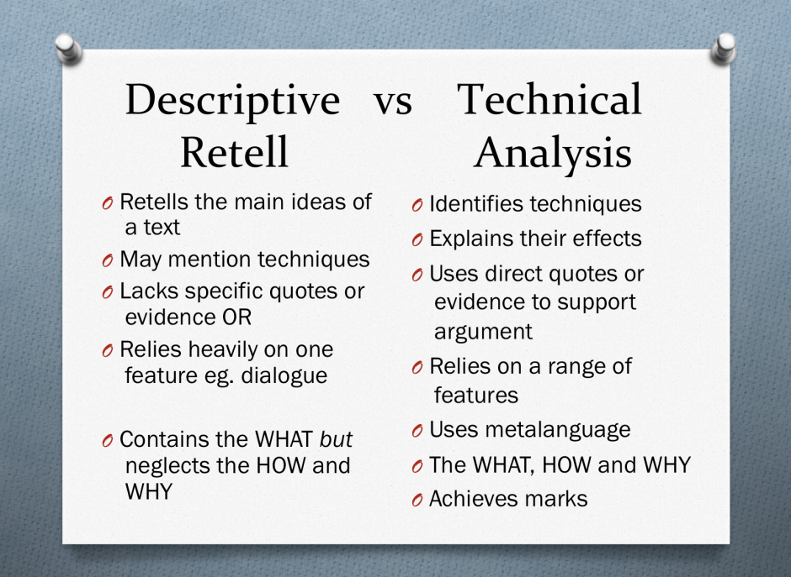
FULLY PREPARED ESSAYS DON’T WORK AS YOU MUST ANSWER THE QUESTION!
Prepare yourself with a range of features, thesis statements, topic sentences and supporting evidence. Craft your introduction and conclusion in response to the question on the day. Have 10 -15 prepared paragraphs and choose the 5 – 8 that best fit the question. Ensure you finish with a solid conclusion.
Make a word bank from the rubric to help you answer potential questions.
DISTINCTIVE – Unique, Exclusive, Peculiar, atypical.
QUALITIES – features, traits, attributes
EVALUATE – Assess, judge, examine
EFFECTIVE – successful, potent, strong
MAKE A JUDGEMENT
“Successfully challenges understanding” or “Potent portrayal of character”
REMEMBER Sleep well before your exams and eat breakfast. A fresh mind helps more than a last minute cram.
You can write notes on the paper. Annotate your question with synonyms to help your writing.
How does Haddon’s portrayal of the relationship between Christopher and his world move us to a deeper understanding of acceptance?

WORLD
Space
Home
Environment
School
Society
CHRISTOPHER
Protagonist
Lead Character
Person
Individual
RELATIONSHIP
Connection
Association
Link
Family ties
PORTRAYAL
Depiction
Demonstrate
Show
Conveys
HOW
Successfully
Impressively
Convincingly
Plausibly

UNDERSTAND
Comprehend
Know
Assume
Insight
Grasp
ACCEPTANCE
Agree
Affirm
Adopt
Welcome
Acknowledge
US
Reader
Audience
Society
People

Remember to use ‘we’, ‘us’ and ‘our’ rather than ‘me’, ‘my’ and ‘I’.

Possible Thesis
Authors seek to broaden our understanding of the world by representing different characters and situations in the novel.
Complete the introduction by stating Haddon’s purpose then firmly outline what we understand it to be. One sentence for each.

